SOURCE CODE

IPO CHART

INPUT | PROCESS | OUTPUT
Physical E-Stop Relay  • Digital Input (GPIO 23)  • Reads High/Low state for safety interrupt line. | 1. Safety Interrupt Evaluation  • Check GPIO 23 state.  • If HIGH, disarm motor immediately and enter lockout state. | Emergency Disarm Signal  • PWM Output: $1500 μ\text{s}$ (Neutral) to 60A ESC.  • Servo Angle: Set to ${90}^{∘}$ (Center).
TF-Luna LiDAR Sensor  • Serial/UART Input (UART1 @ 115,200 baud)  • Distance measurement ahead in centimetres ($\text{cm}$). | 2. Obstacle Detection & Braking  • Parse UART distance packet.  • Evaluate if $\text{Distance}<30 \text{cm}$.  • If TRUE, trigger dynamic braking override ($100 \text{ms}$ pause). | Emergency Brake Command  • PWM Output: $1500 μ\text{s}$ (Neutral) to 60A ESC.  • Throttle held at 0%.
Left Sharp IR Sensor  • Analog Input (GPIO 34)  • ADC value ($0-4095$) converted to distance ($\text{cm}$). | 3. Track Centering Error Calculation  • Calculate lateral differential error:  $$\text{Error}=\text{Left Distance}-\text{Right Distance}$$ | Error Value ($e$)  • Positive = Drifted right (steer left).  • Negative = Drifted left (steer right).
Right Sharp IR Sensor  • Analog Input (GPIO 35)  • ADC value ($0-4095$) converted to distance ($\text{cm}$). | 4. PID Closed-Loop Steering Control  • Proportional: $P=K_{p}⋅e$  • Integral: $I=K_{i}⋅\int{e} dt$ (Clamped: $-50$ to $50$)  • Derivative: $D=K_{d}⋅\frac{de}{dt}$  • Total Adjustment $=P+I+D$ | Raw Target Servo Angle  $$\text{Angle}={90}^{∘}+\text{Adjustment}$$
Hardware & Mechanical Limits  • Servo Min Angle: ${55}^{∘}$  • Servo Max Angle: ${125}^{∘}$  • Target Loop Frequency: $250 \text{Hz}$ ($4 \text{ms}$) | 5. Output Signal Constraining & Timing  • Clamp steering angle between ${55}^{∘}$ and ${125}^{∘}$.  • Execute $4 \text{ms}$ delay to maintain strict $250 \text{Hz}$ execution rate. | Physical Actuation Outputs  • DS3218 Servo (GPIO 18): PWM angle (${55}^{∘}-{125}^{∘}$).  • 60A ESC (GPIO 19): PWM signal ($1580 μ\text{s}$ drive pulse).

FLOW CHART

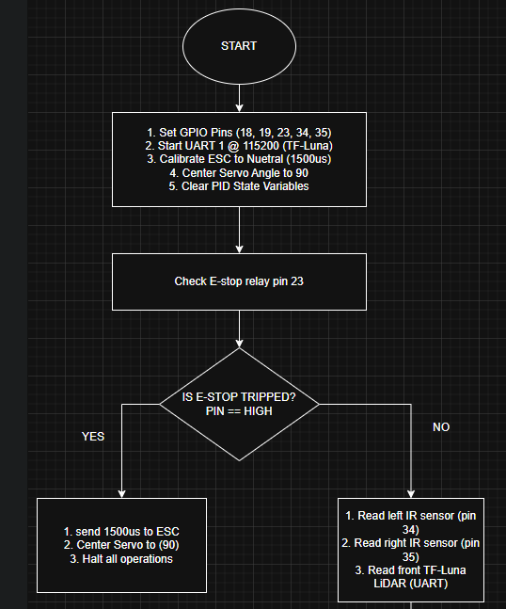
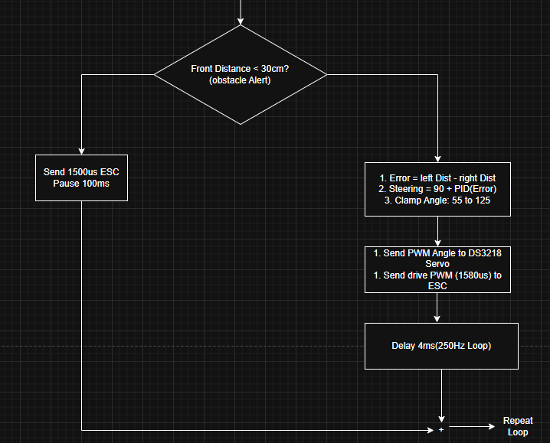

ARDUINO IDE CODE

#include <Arduino.h>
#include <ESP32Servo.h>

// ============================================================================
// 1. HARDWARE PIN DEFINITIONS & CONSTANTS
// ============================================================================
#define SERVO_PIN 18 // DS3218MG Digital Steering Servo
#define ESC_PIN 19 // 60A Brushless ESC Motor Driver
#define ESTOP_RELAY_PIN 23 // Latching E-Stop Hardware Input
#define LEFT_IR_PIN 34 // Left Sharp GP2Y0A21YK0F Analog IR
#define RIGHT_IR_PIN 35 // Right Sharp GP2Y0A21YK0F Analog IR

#define TF_LUNA_RX 16 // ESP32 RX2 connected to TF-Luna TX
#define TF_LUNA_TX 17 // ESP32 TX2 connected to TF-Luna RX

// Actuator Bounds & Calibrations
#define SERVO_CENTER_DEG 90
#define SERVO_MIN_DEG 55 // Clamped Maximum Left Turn Angle
#define SERVO_MAX_DEG 125 // Clamped Maximum Right Turn Angle

#define ESC_NEUTRAL_US 1500 // Neutral / Stop Signal (microseconds)
#define ESC_FORWARD_US 1580 // Target Forward Drive Speed (microseconds)

// Timing Control (250 Hz = 4 ms per loop)
#define TARGET_LOOP_HZ 250
const unsigned long LOOP_TIME_US = 1000000 / TARGET_LOOP_HZ;

// ============================================================================
// 2. EMBEDDED PID CONTROLLER CLASS
// ============================================================================
class PIDController {
private:
float kp, ki, kd;
float prevError;
float integral;
float minOutput, maxOutput;

public:
PIDController(float p, float i, float d, float minOut, float maxOut)
: kp(p), ki(i), kd(d), minOutput(minOut), maxOutput(maxOut), prevError(0.0f), integral(0.0f) {}

void reset() {
prevError = 0.0f;
integral = 0.0f;
}

float compute(float setpoint, float currentVal, float dt) {
float error = setpoint - currentVal;

// Proportional term
float pTerm = kp * error;

// Integral term with anti-windup clamping (-50 to 50)
integral += error * dt;
integral = constrain(integral, -50.0f, 50.0f);
float iTerm = ki * integral;

// Derivative term
float derivative = (dt > 0.0f) ? (error - prevError) / dt : 0.0f;
float dTerm = kd * derivative;

prevError = error;

// Calculate raw angle output centered around 90 degrees
float output = 90.0f + (pTerm + iTerm + dTerm);
return constrain(output, minOutput, maxOutput);
}
};

// ============================================================================
// 3. GLOBAL HARDWARE OBJECTS & STATE VARIABLES
// ============================================================================
Servo steeringServo;
Servo escMotor;

// PID Tuning Constants: Kp=1.8, Ki=0.05, Kd=0.4
PIDController pid(1.8f, 0.05f, 0.4f, SERVO_MIN_DEG, SERVO_MAX_DEG);

unsigned long lastLoopTime = 0;

// ============================================================================
// 4. HELPER FUNCTION DECLARATIONS
// ============================================================================
int readTFLunaDistance() {
HardwareSerial &lidarSerial = Serial2;
if (lidarSerial.available() >= 9) {
if (lidarSerial.read() == 0x59 && lidarSerial.read() == 0x59) { // Header bytes
uint8_t lowByte = lidarSerial.read();
uint8_t highByte = lidarSerial.read();

// Clear remaining 5 frame bytes from serial buffer
for (int i = 0; i < 5; i++) {
lidarSerial.read();
}
return (highByte << 8) | lowByte; // Distance in cm
}
}
return -1; // Return -1 if no valid frame available
}

float readAnalogDistance(int pin) {
int rawADC = analogRead(pin);
if (rawADC < 100) return 80.0f; // Default out-of-range fallback

// Convert 12-bit ADC (0-4095) at 3.3V to approximate distance in cm
float voltage = rawADC * (3.3f / 4095.0f);
float distanceCm = 27.86f * pow(voltage, -1.15f);
return constrain(distanceCm, 10.0f, 80.0f);
}

// ============================================================================
// 5. SETUP ROUTINE
// ============================================================================
void setup() {
// Start Serial Communications
Serial.begin(115200);
Serial2.begin(115200, SERIAL_8N1, TF_LUNA_RX, TF_LUNA_TX);

// Configure GPIO Pin Modes
pinMode(ESTOP_RELAY_PIN, INPUT_PULLUP);
pinMode(LEFT_IR_PIN, INPUT);
pinMode(RIGHT_IR_PIN, INPUT);

// Allocate Hardware Timers for ESP32 Servo Library
ESP32PWM::allocateTimer(0);
ESP32PWM::allocateTimer(1);

steeringServo.setPeriodHertz(50);
escMotor.setPeriodHertz(50);

steeringServo.attach(SERVO_PIN, 500, 2500);
escMotor.attach(ESC_PIN, 1000, 2000);

// Set Initial Safe States
steeringServo.write(SERVO_CENTER_DEG);
escMotor.writeMicroseconds(ESC_NEUTRAL_US);

// Delay 2 seconds for ESC arming/calibration signal to settle
delay(2000);
lastLoopTime = micros();
}

// ============================================================================
// 6. MAIN CONTROL LOOP (250 Hz Deterministic Loop)
// ============================================================================
void loop() {
unsigned long currentMicros = micros();

// Enforce strict 4ms (250 Hz) execution timing
if (currentMicros - lastLoopTime >= LOOP_TIME_US) {
float dt = (currentMicros - lastLoopTime) / 1000000.0f;
lastLoopTime = currentMicros;

// --------------------------------------------------------------------
// HARDWARE SAFETY CHECK: E-Stop State Interrupt
// --------------------------------------------------------------------
if (digitalRead(ESTOP_RELAY_PIN) == HIGH) {
escMotor.writeMicroseconds(ESC_NEUTRAL_US); // Neutral throttle
steeringServo.write(SERVO_CENTER_DEG); // Straight steering
pid.reset();
return; // Halt further execution
}

// --------------------------------------------------------------------
// STEP 1: SEE (PERCEPTION)
// --------------------------------------------------------------------
int frontDistanceCm = readTFLunaDistance();
float leftDistCm = readAnalogDistance(LEFT_IR_PIN);
float rightDistCm = readAnalogDistance(RIGHT_IR_PIN);

// --------------------------------------------------------------------
// SAFETY OVERRIDE: Emergency Brake (<30 cm obstacle alert)
// --------------------------------------------------------------------
if (frontDistanceCm > 0 && frontDistanceCm < 30) {
escMotor.writeMicroseconds(ESC_NEUTRAL_US);
steeringServo.write(SERVO_CENTER_DEG);
delay(100);
return;
}

// --------------------------------------------------------------------
// STEP 2: THINK (CONTROL - PID Wall Centering)
// --------------------------------------------------------------------
// Error = Left Distance - Right Distance. Setpoint = 0.0 (Equal spacing)
float currentError = leftDistCm - rightDistCm;
float targetAngle = pid.compute(0.0f, currentError, dt);

// --------------------------------------------------------------------
// STEP 3: ACT (ACTUATION)
// --------------------------------------------------------------------
steeringServo.write((int)targetAngle);
escMotor.writeMicroseconds(ESC_FORWARD_US);
}
}

